Lesson 1:
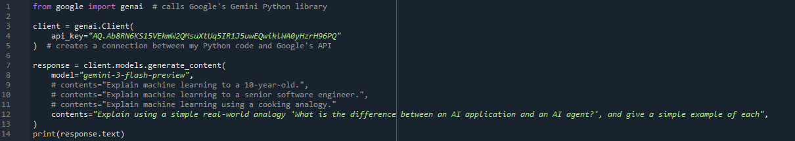
- from google import genai
calls Google's Gemini Python library
- client = genai.Client( api_key="AQ.Ab8RN6KS15VEkmW2QMsuXtUq5IR1J5uwEQwiklWA0yHzrH96PQ")
creates a connection between my Python code and Google's API
how did I find my API key?
- Go to Google AI Studio (aistudio.google.com) and sign in with your Google account.
- Click Get API key (in the left sidebar or top area).
- Click Create API key. You may be asked to pick or create a Google Cloud project; choosing the default or creating a new one is fine.
- Copy the key. It's a long string, usually starting with AIza....

- response = client.models.generate_content(
model="gemini-3-flash-preview",
contents="Explain using a simple real-world analogy 'What is the difference between an AI application and an AI agent?', and give a simple example of each",
)

